**What is the purpose of the core module in AEM?**

The core module is also known as core components which is ready to use, flexible building blocks for creating websites. It makes life easier for developers by providing standardized, reusable and customizable components . These components are designed to be accessible, responsive and for better performance.

**What kind of files and code can be found in the core folder?**

The core folder in AEM is like the engine room of your project. It contains the backend Java code and configurations that power your AEM components and functionality.It can be find inside Java classes,OSGi configurations,dialogs and design dialogs , client libraries etc..

**Explain the role of ui.apps in AEM projects.**

The role of ui.apps module plays a crucial role in managing the frontend and authoring-related aspects of your website. It contains everything that defines how your site looks, behaves, and is edited by content authors like it stores Frontend code and components, Handles Static Resources, Supports Component Development, Facilitates Deployment etc.

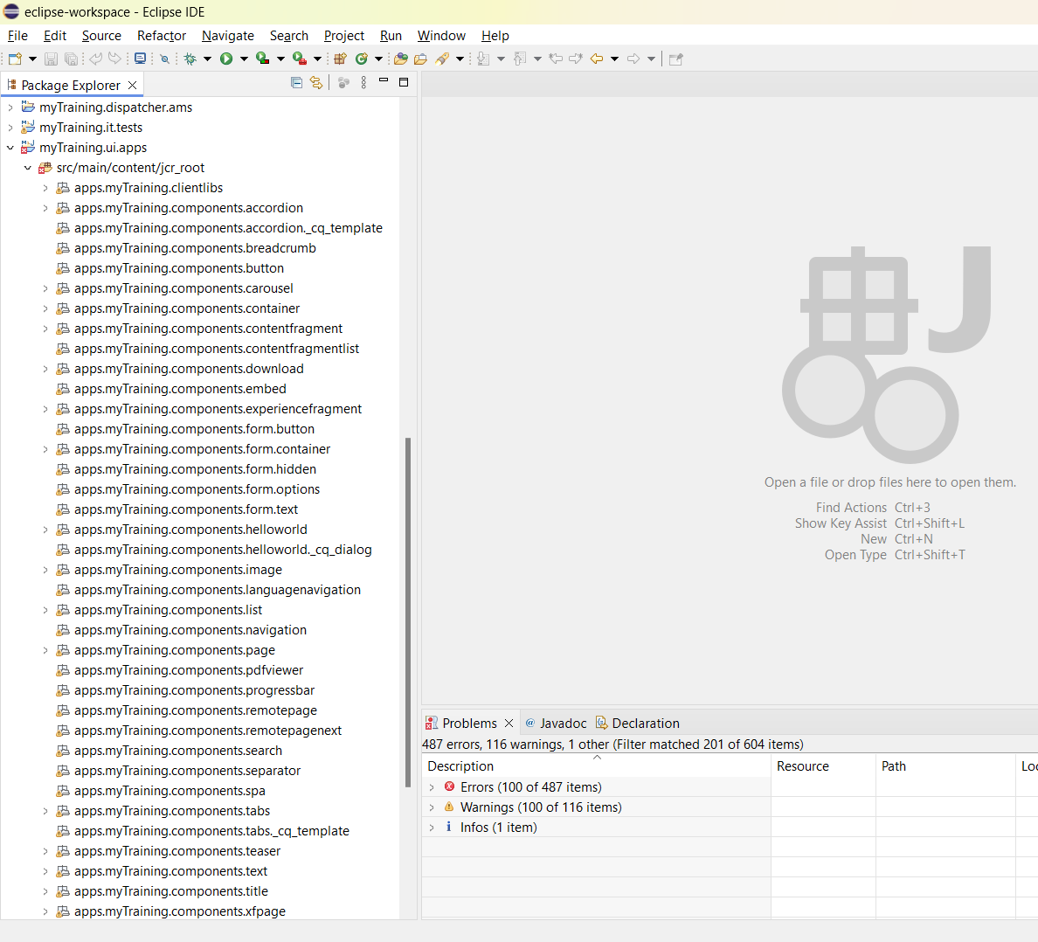

**How are components structured in the ui.apps folder?**

The components in the ui.apps  folder are structured in a way that ensures clarity, reusability, and maintainability. Each component is organized into its own folder, containing the necessary files for rendering, authoring, and styling.

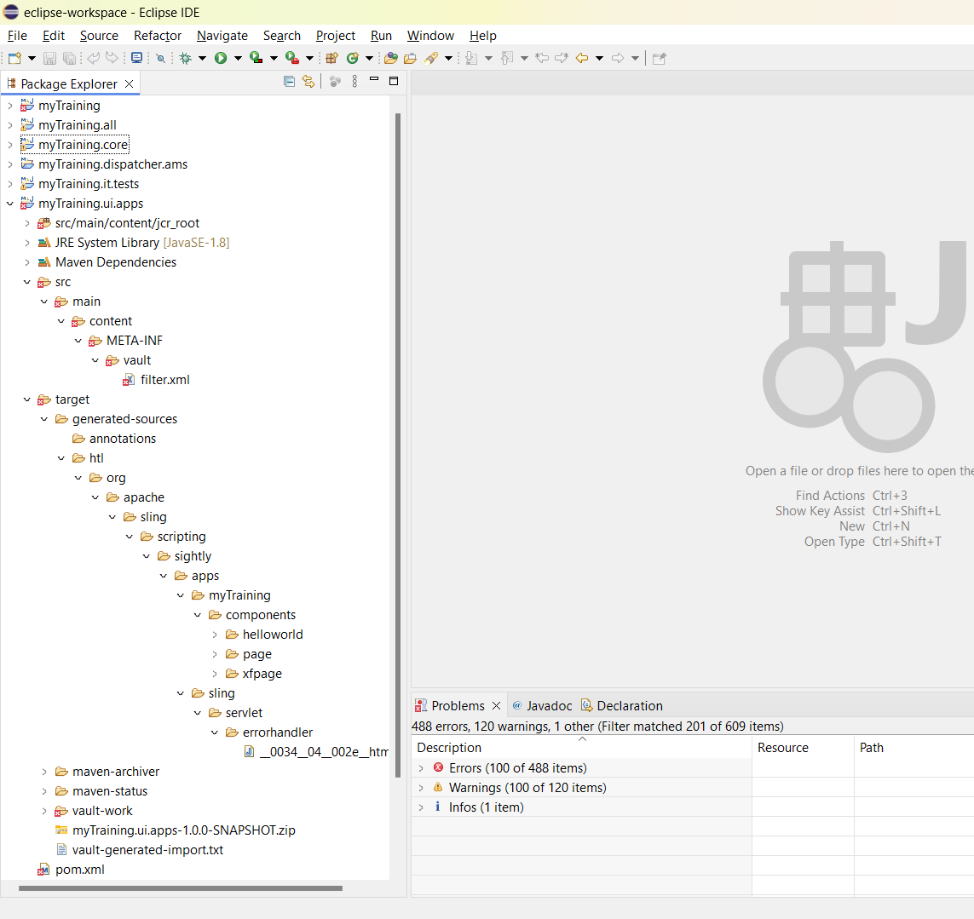

**Hello World Component:**

* **Where is the Hello World component located in both core and ui.apps?**

In core the Hello World component is located in the src/main/java directory as a Java class. In ui.apps the Hello World component is located in the apps/<project>/components/helloworld directory with HTL scripts and client libraries.

* **Explain the Java class (in core) for the Hello World component.**

The Java class in the core module for the Hello World component typically extends a Sling Model . It contains logic to fetch and process data to be displayed in the front-end component.

* **How does the HTL script work in ui.apps for Hello World?**

The HTL script in ui.appsfor the Hello World component uses HTML Template Language to render the component's markup. It accesses properties and methods from the

backend Java class to display dynamic content.

* **How are properties and dialogs defined for this component?**

Properties and dialogs for the Hello World component are defined using XML in the

ui.apps module. These configurations allow authors to enter and manage content in the AEM authoring interface

**What are the different types of AEM modules (core, ui.apps, ui.content, etc.)?**

AEM projects typically include core, ui.apps, ui.content, and ui.config modules. Each module serves a specific purpose, from backend logic to front-end components and content structure.

**How does Maven build these modules?**

Maven builds AEM modules by executing lifecycle phases defined in the pom.xml files. It compiles code, processes resources, packages artifacts, and installs them to local or remote repositories.

**Explain the build lifecycle of Maven in the context of AEM.**

The Maven build lifecycle in AEM involves phases such as validate, compile, test, package, verify, install, and deploy. Each phase performs specific tasks to ensure a smooth build and deployment process.

**How are dependencies managed in pom.xml?**

Dependencies in pom.xml are managed using <dependencies> and<dependencyManagement> sections. Maven resolves and downloads the required libraries, ensuring that the project has the necessary dependencies.

**Why is Maven used instead of other build tools?**

Maven is preferred because it simplifies dependency management, supports a standardized project structure, and integrates well with CI/CD pipelines. Its extensive plugin ecosystem also enhances build automation.

**What advantages does Maven offer for AEM development?**

Maven offers structured build processes, dependency management, and plugin support, making it easier to manage and maintain AEM projects. It streamlines the development workflow and ensures consistency

**How does Maven help in managing dependencies and plugins in AEM projects?**

Maven manages dependencies and plugins through pom.xml. It downloads and caches required libraries and plugins, ensuring that the project has the necessary tools and libraries to build and deploy AEM components.

**What does mvn clean install do in an AEM project?**

The mvn clean install command cleans the project, compiles the code, runs tests, packages the artifacts, and installs them to the local repository. It ensures that the project is built and ready for deployment.

**How to deploy packages directly to AEM using Maven commands?**

You can deploy packages directly to AEM using commands like mvn -PautoInstallPackage install. This command builds and installs the package to the AEM instance specified in the pom.xml configuration.

**Explain the purpose of different Maven profiles in AEM (autoInstallPackage, autoInstallBundle).**

Maven profiles, such as autoInstallPackage and autoInstallBundle, allow you to define different build configurations. They enable you to customize the build process based on the environment or specific requirements.

**What is the purpose of dumplibs in AEM?**

dumplibs helps generate a single client library file by bundling all required JavaScript and CSS. It improves page load times by reducing the number of HTTP requests needed to load client-side resources.

**How can you view client libraries using dumplibs?**

You can view client libraries generated by dumplibs in the AEM author's "Client Libraries" section. They are bundled into a single file, making it easier to manage and optimize client-side assets.

**Explain how client libraries are structured in AEM.**

Client libraries in AEM are organized into folders containing JavaScript, CSS, and other assets. Each client library is defined in an XML configuration, specifying dependencies, categories, and other metadata.

